MasterClass Project

- We need to setup webserver on vm instance
- Install mysql client
- Test the connectivity
- Create sample php project
- Connect to db
- Update table

Step 1: Install web server package

sudo apt update
sudo apt install apache2 php php-mysql -y
sudo systemctl start apache2
sudo systemctl enable apache2

step 2: Install mysql client

Download the package:
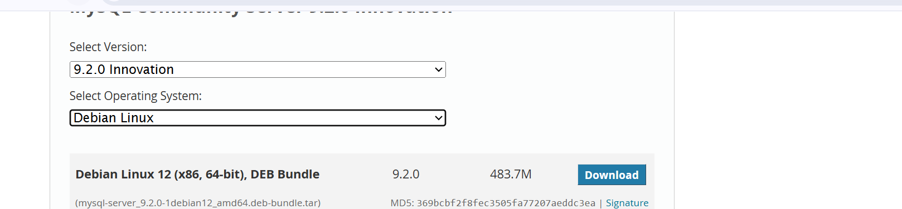

Copy the link
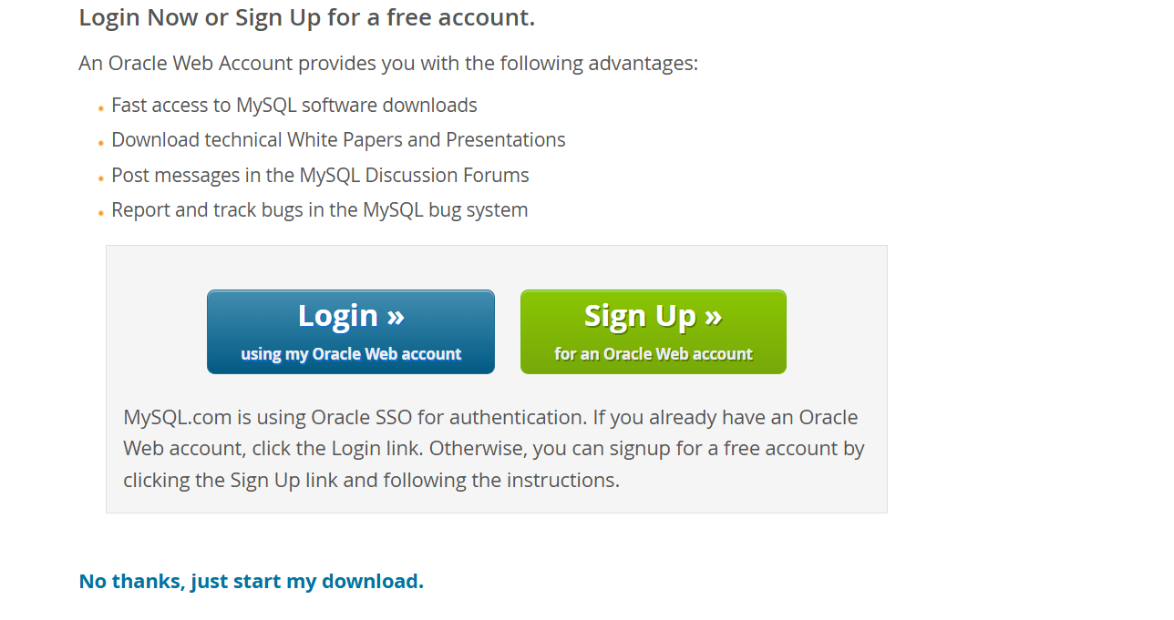
mkdir mysql
cd mysql
wget https://dev.mysql.com/get/Downloads/MySQL-9.2/mysql-server_9.2.0-1debian12_amd64.deb-bundle.tar
tar xvf mysql-server_9.2.0-1debian12_amd64.deb-bundle.tar

Install package in this order
sudo apt install mysql-client -y
sudo su
dpkg -i mysql-community-client-plugins_9.2.0-1debian12_amd64.deb
dpkg -i mysql-community-client-core_9.2.0-1debian12_amd64.deb
dpkg -i mysql-common_9.2.0-1debian12_amd64.deb
dpkg -i mysql-community-client_9.2.0-1debian12_amd64.deb
dpkg -i mysql-client_9.2.0-1debian12_amd64.deb

Note down your SQL instance private ip

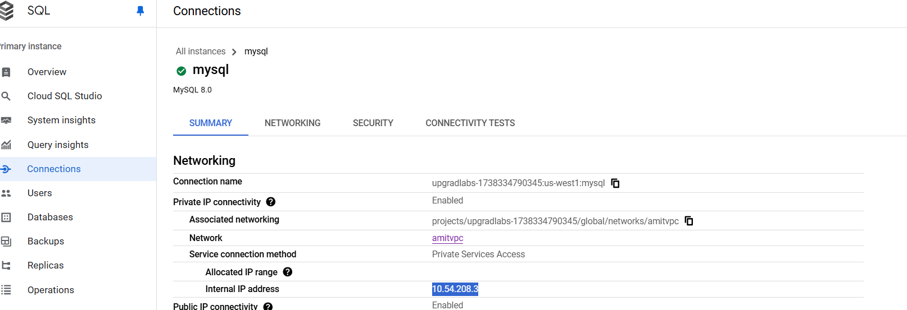

Run from the host
Please provide your sql instance private ip, highlighted in red
mysql --ssl-mode=DISABLED --host= database-1.cb8kqa0a4fj0.us-east-1.rds.amazonaws.com --user=admin --password

Create DB, create table and insert
CREATE DATABASE mydb;
USE mydb;
SHOW TABLES;
DESCRIBE users;
CREATE TABLE users (
id INT AUTO_INCREMENT PRIMARY KEY,
name VARCHAR(100) NOT NULL,
email VARCHAR(100) NOT NULL UNIQUE
);
INSERT INTO users (name, email) VALUES ('John Doe', 'john@example.com');

Exit from mysql prompt : Type “exit”

Step 3: Add php code
Go to /var/www/html directory

cd /var/www/html
nano db_connect.php, modify the below code highlighted in red and add
<?php
$servername = "10.123.112.3"; // Change this to your MySQL server's private IP or hostname
$username = "root";
$password = "Welcome1";
$database = "mydb"; // Database name
// Create connection
$conn = new mysqli($servername, $username, $password, $database);
// Check connection
if ($conn->connect_error) {
die("Connection failed: " . $conn->connect_error);
}
echo "Connected successfully to MySQL!";
// Create Database
$sql = "CREATE DATABASE IF NOT EXISTS mydb";
if ($conn->query($sql) === TRUE) {
echo "Database created successfully";
} else {
echo "Error creating database: " . $conn->error;
}
?>

Add your db instance ip, password and db name: Example screenshot
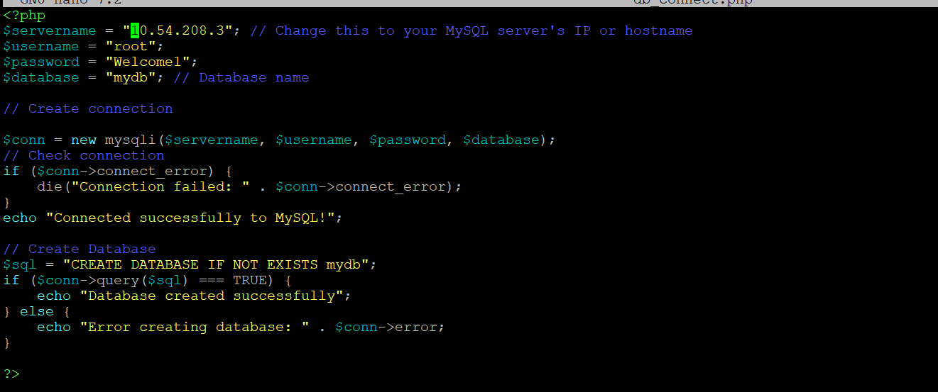

Restart apache2
systemctl restart apache2

Open using external(public) ip of cloud vm (Webserver)
http://34.105.42.167/db_connect.php

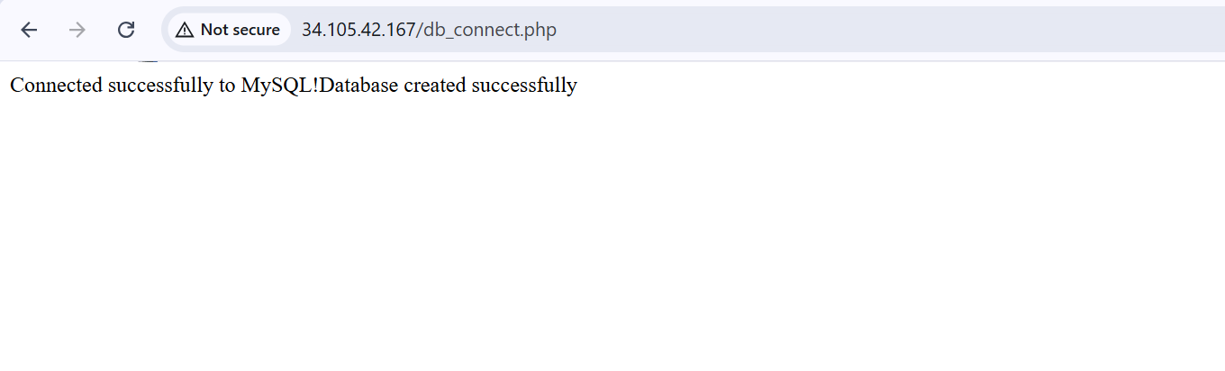

Add few more file to enhance the code, in /var/www/html location
File name: index.php and add below code
<?php
include 'db_connect.php';
// Ensure the connection is still open
if (!isset($conn) || $conn->connect_error) {
die("Database connection failed.");
}
// Fetch users from the database
$result = $conn->query("SELECT * FROM users");
if (!$result) {
die("Query failed: " . $conn->error);
}
?>
<!DOCTYPE html>
<html>
<head>
<title>Users List</title>
</head>
<body>
<h2>Users</h2>
<table border="1">
<tr><th>ID</th><th>Name</th><th>Email</th><th>Actions</th></tr>
<?php while ($row = $result->fetch_assoc()): ?>
<tr>
<td><?= htmlspecialchars($row['id']) ?></td>
<td><?= htmlspecialchars($row['name']) ?></td>
<td><?= htmlspecialchars($row['email']) ?></td>
<td>
<a href="edit.php?id=<?= $row['id'] ?>">Edit</a> |
<a href="delete.php?id=<?= $row['id'] ?>" onclick="return confirm('Are you sure?')">Delete</a>
</td>
</tr>
<?php endwhile; ?>
</table>
<a href="add.php">Add User</a>
</body>
</html>
<?php
// Close connection
$conn->close();
?>

File name: add.php
<?php
include 'db_connect.php';
if ($_SERVER["REQUEST_METHOD"] == "POST") {
$name = $_POST['name'];
$email = $_POST['email'];
$stmt = $conn->prepare("INSERT INTO users (name, email) VALUES (?, ?)");
$stmt->bind_param("ss", $name, $email);
if ($stmt->execute()) {
header("Location: index.php");
} else {
echo "Error: " . $stmt->error;
}
}
?>
<!DOCTYPE html>
<html>
<head>
<title>Add User</title>
</head>
<body>
<h2>Add User</h2>
<form method="POST">
Name: <input type="text" name="name" required><br>
Email: <input type="email" name="email" required><br>
<button type="submit">Add</button>
</form>
<a href="index.php">Back</a>
</body>
</html>

File name: delete.php
<?php
include 'db_connect.php';
$id = $_GET['id'];
$stmt = $conn->prepare("DELETE FROM users WHERE id=?");
$stmt->bind_param("i", $id);
if ($stmt->execute()) {
header("Location: index.php");
} else {
echo "Error: " . $stmt->error;
}
?>

File name: edit.php
<?php
include 'db_connect.php';

$id = $_GET['id'];

if ($_SERVER["REQUEST_METHOD"] == "POST") {
$name = $_POST['name'];
$email = $_POST['email'];

$stmt = $conn->prepare("UPDATE users SET name=?, email=? WHERE id=?");
$stmt->bind_param("ssi", $name, $email, $id);

if ($stmt->execute()) {
header("Location: index.php");
} else {
echo "Error: " . $stmt->error;
}
}

$result = $conn->query("SELECT * FROM users WHERE id=$id");
$user = $result->fetch_assoc();
?>

<!DOCTYPE html>
<html>
<head>
<title>Edit User</title>
</head>
<body>
<h2>Edit User</h2>
<form method="POST">
Name: <input type="text" name="name" value="<?= $user['name'] ?>" required><br>
Email: <input type="email" name="email" value="<?= $user['email'] ?>" required><br>
<button type="submit">Update</button>
</form>
<a href="index.php">Back</a>
</body>
</html>

Restart the service
systemctl restart apache2

Connect to external ip of cloud vm instance
http://34.105.42.167/index.php
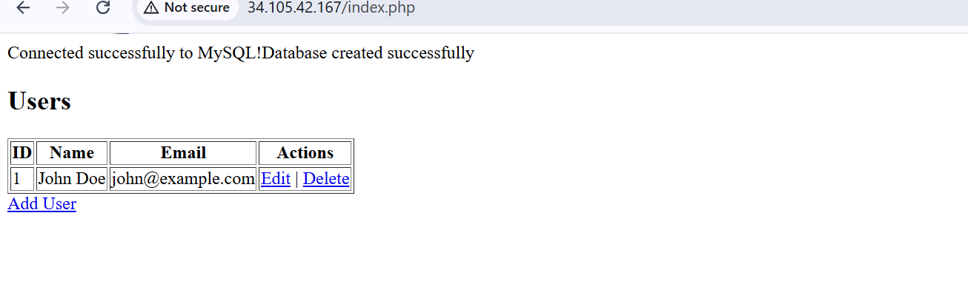

Take the backup
